UCS 1611 - Internet Programming Lab **Exercise 7: Website for International Conference using React**

**Swetha Saseendran**

**CSE-C**

**185001183**

**Learning objective:**

To design a Website for an International Conference using React.

**Specifications:**

1. The conference homepage should consists of the following tabs:

Home, Committee, Call For Papers, Important Dates, Workshops,

Registration and Contact.

1. On clicking each tab, it should open in the same page (SPA). (Use react

router)

1. The website should contain logos, header, footer.
2. The Header and footer should be same for all links.
3. For pre-conference workshop registration use form elements.

**Code**

**index.html**

<html>

<head>

  <!-- ICONS -->

  <link rel="stylesheet" href="https://cdnjs.cloudflare.com/ajax/libs/font-awesome/4.7.0/css/font-awesome.min.css">

  <!-- FONT LINKS -->

  <link rel="preconnect" href="https://fonts.gstatic.com">

  <link href="https://fonts.googleapis.com/css2?family=Bree+Serif&family=Pacifico&display=swap" rel="stylesheet">

  <!-- CSS FILE  -->

</head>

<body>

  <div id="header"></div>

  <div id="root"></div>

  <div id="footer"></div>

</body>

</html>

**Index.js**

import React from "react";

import ReactDOM from "react-dom";

import App from "./Components/App";

ReactDOM.render(<App />, document.getElementById("root"));

**Topbar.js**

import "./style.css";

import React, { Component } from "react";

import { BrowserRouter, Link } from "react-router-dom";

export default *function* Topbar() {

  return (

    <div>

      <nav>

        <a>

          <Link to="/">Home</Link>

        </a>

        <a>

          <Link to="/commitee">Commitee</Link>

        </a>

        <a>

          <Link to="/call">Call For Papers</Link>

        </a>

        <a>

          <Link to="/imp">Important Dates</Link>

        </a>

        <a>

          <Link to="/workshop">Workshops</Link>

        </a>

        <a>

          <Link to="/registration">Register</Link>

        </a>

        <a>

          <Link to="/contact">Contact Us</Link>

        </a>

      </nav>

    </div>

  );

}

**Footer.js**

import "./style.css";

import React, { Component } from "react";

export default *function*() {

  return (

    <div>

      <br />

      <br />

      <div className="wrap">

        <div className="cont">

          <div className="box google" style={{ textAlign: "center" }}>

            <i className="fa fa-google" style={{ marginTop: "10px" }} />

          </div>

        </div>

        <div className="cont">

          <div className="box facebook" style={{ textAlign: "center" }}>

            <i className="fa fa-facebook" style={{ marginTop: "10px" }} />

          </div>

        </div>

        <div className="cont">

          <div className="box linkedin" style={{ textAlign: "center" }}>

            <i className="fa fa-linkedin" style={{ marginTop: "10px" }} />

          </div>

        </div>

        <div className="cont">

          <div className="box twitter" style={{ textAlign: "center" }}>

            <i className="fa fa-twitter" style={{ marginTop: "10px" }} />

          </div>

        </div>

        <div className="cont">

          <div className="box youtube" style={{ textAlign: "center" }}>

            <i className="fa fa-youtube" style={{ marginTop: "10px" }} />

          </div>

        </div>

      </div>

      <footer>

        <p align="center" style={{ color: "white" }}>

          © Copyright All Rights Reserved 2021

        </p>

      </footer>

    </div>

  );

}

**App.js**

import React from "react";

import "./style.css";

import { BrowserRouter as Router, Switch, Route } from "react-router-dom";

import Topbar from "./Components/Topbar";

import Footer from "./Components/Footer";

import Home from "./Components/Home";

import Commitee from "./Components/Commitee";

import Call from "./Components/Call";

import Important from "./Components/Important";

import Workshop from "./Components/Workshop";

import Register from "./Components/Register";

import Contact from "./Components/Contact";

export default *function* App() {

    return (

        <div >

            <Router >

                <Topbar / >

                <Switch >

                <Route exact path = "/" >

                    <Home / >

                </Route>

                <Route path = "/commitee" >

                    <Commitee / >

                </Route>

                <Route path = "/call" >

                    <Call / >

                </Route>

                <Route path = "/imp" >

                    <Important / >

                </Route>

                <Route path = "/workshop" >

                    <Workshop / >

                </Route>

                <Route path = "/registration" >

                    <Register / >

                </Route>

                <Route path = "/contact" >

                    <Contact/>

                </Route>

                </Switch >

                <Footer/>

            </Router>

        </div>

    );

}

**Home.js**

import "./style.css";

import React, { Component } from "react";

export default *function* Home() {

  return (

    <body>

      <br />

      <br />

      <br />

      <br />

      <marquee style={{ margin: "10px" }}>

        <h3>

          Marquee Text: The conference footer would appear on all pages. The

          text is as follows, on a single centred line: 2019 International

          Conference on Indoor Positioning and Indoor Navigation (IPIN), 30

          Sept. - 3 Oct. 2019, Pisa, Italy

        </h3>

      </marquee>

      <div className="element" />

      <div style={{ margin: "40px", marginLeft: "55px" }}>

        <h1>ABOUT US</h1>

      </div>

      <article className="container">

        <section>

          <p>

            International Conference Alerts provides details about the upcoming

            academic conferences, seminars and workshops to be held worldwide.

            Academician and professionals can get their relevant updates and

            conference alerts through International conference alerts.

            International Conference Alerts provides a free subscription to its

            users with email notifications about upcoming Medical conferences,

            Engineering conferences, Business and Economics, Science and

            education and various conferences. Users can register and subscribe

            to get free conference alerts regarding upcoming international

            conferences 2021 at Dubai, Germany, Singapore, Thailand, USA as well

            as all major cities and countries across the world. This is the

            exact reason why internationalconferencealerts.com was established -

            to provide the masses, up-to-date and incredibly reliable

            information on all upcoming conferences, in a variety of fields.

          </p>

        </section>

        <section>

          <p>

            Many prominent and successful researchers, scientists and scholars

            have attributed their success to international conferences that they

            attended early on in their careers. They cited the great learning,

            networking, and collaborative opportunities that these conferences

            present, as being the reason for their success. International

            Conference Alerts offers conference organizers/planners the

            provision to better target potential conference delegates by

            allowing them to add details about their upcoming events to our

            existing conference listings. Numerous conference organizers and

            planners have witnessed remarkable growth in attendance at their

            events, after posting information about these events on our website!

            So take advantage of these provisions and expand your career or

            learn more about the latest developments in your field, today.

          </p>

        </section>

      </article>

    </body>

  );

}

**Call.js**

import "./style.css";

import React, { Component } from "react";

export default *function* Call() {

  return (

    <body>

      <br />

      <br />

      <div style={{ margin: "40px", marginLeft: "55px" }}>

        <h1>Conference Call for Papers</h1>

      </div>

      <article className="container">

        <p>

          The 3rd International Conference on Advanced Research in Social

          Sciences (ICARSS), March 11 – 14, 2021 in Oxford, United Kingdom, is

          the premier forum for the presentation of new advances and research

          results in education theory and practice.

        </p>

        <p>

          This conference is a prestigious event, organized to provide an

          international platform for the academicians, researchers, managers,

          industrial participants and students to share their research findings

          with global experts. All full paper submissions will be peer reviewed

          and evaluated based on originality, technical and/or research depth,

          accuracy and relevance to conference call for papers.

        </p>

        <a style={{ color: "rgb(76, 76, 207)" }}>

          <em>Submission Format</em>

        </a>

        <br />

        Authors must follow the Springer LNCS formatting instructions. For

        camera-ready papers use Latex or Word style. Each paper will receive at

        least three reviews. At least one author of each accepted paper must

        register by the early registration date indicated on the conference

        website and present the paper.

      </article>

      <article className="sidebyside" style={{ clear: "both" }}>

        <section className="left">

          <aside>

            <h3>Sociology</h3>

            <ul>

              <li>Aging</li>

              <li>Applied Anthropology</li>

              <li>Archaeology</li>

              <li>Black Lives Matter</li>

              <li>Elderly care</li>

              <li>Child Research</li>

              <li>Childhood Development & Schooling</li>

            </ul>

          </aside>

        </section>

        <section className="right">

          <h2>Philosophy</h2>

          <ul>

            <li>Pragmatism</li>

            <li>Realism</li>

            <li>Romanticism</li>

            <li>Social Philosophy</li>

            <li>Transcendentalism</li>

            <li>Utilitarianism</li>

            <li>Western Philosophy</li>

          </ul>

        </section>

        <br />

      </article>

      <br />

      <br />

    </body>

  );

}

**Committee.js**

import "./style.css";

import React, { Component } from "react";

export default *function* Commitee() {

  return (

    <body>

      <br />

      <br />

      <div style={{ margin: "40px", marginLeft: "55px" }}>

        <h1>International Conference Committees</h1>

      </div>

      <div className="container">

        <ol>

          <li>

            11th International Meeting on DNA Computing (DNA11), London, June

            2005 - Organizing Committee Chair.

          </li>

          <li>

            10th International Meeting on DNA Computing (DNA10), Milano, Italy,

            June 2004 - Program Committee Member.

          </li>

          <li>

            Descriptional Complexity of Formal Systems, DCFS 2004 - Program

            Committee Member.

          </li>

          <li>

            U.S. Frontiers of Engineering 2003, (U.S. National Academy of

            Engineering), California, September 2003 - Organizing Committee

            Member.

          </li>

          <li>

            Descriptional Complexity of Formal Systems, DCFS 2003, July 2003,

            Budapest, Hungary - Program Committee Member.

          </li>

          <li>

            9th International Meeting on DNA-Based Computers (DNA9), June 2003,

            Madison, Wisconsin - Program Committee Member.

          </li>

          <li>

            Genetic and Evolutionary Computation Conference, GECCO-2002, New

            York, July 2002 - Program Committee Member.

          </li>

          <li>

            8th International Meeting on DNA-Based Computers (DNA8), Sapporo,

            Japan, June 2002 - Program Committee Member.

          </li>

          <li>

            Fifth International Conference Developments in Language Theory, DLT

            2001, Wien Austria, July 16-21, 2001 - Program Committee Member.

          </li>

          <li>

            Congress on Evolutionary Computation (CEC2001) Seoul, Korea, May

            27-30, 2001 - Organizing Committee Member.

          </li>

          <li>

            7th International Meeting on DNA-Based Computers (DNA7), June 2001,

            Tampa, Florida - Program Committee Member.

          </li>

          <li>

            SPIRE'2000 - String Processing and Information REtrieval, September

            27 - 29, 2000, A Coruna, Spain - Program Committee Member.

          </li>

        </ol>

      </div>

    </body>

  );

}

**Contact.js**

import "./style.css";

import React, { Component } from "react";

export default *function* Contact() {

  return (

    <body>

      <br />

      <br />

      <div style={{ margin: "40px", marginLeft: "55px" }}>

        <h1>Contact Us:</h1>

      </div>

      <section className="container">

        <h2 style={{ color: "#334467", textAlign: "center" }}>

          Dr.S.Simon Corwell

        </h2>

        <h4 style={{ textAlign: "center" }}>simon_c45@gmail.com</h4>

        <h2 style={{ color: "#334467", textAlign: "center" }}>

          Dr.Elizabeth Olsen

        </h2>

        <h4 style={{ textAlign: "center" }}>elle_ashley@gmail.com</h4>

        <h2 style={{ color: "#334467", textAlign: "center" }}>

          Dr.Stark Banner

        </h2>

        <h4 style={{ textAlign: "center" }}>banner_stone78@gmail.com</h4>

      </section>

    </body>

  );

}

**Important.js**

import "./style.css";

import React, { Component } from "react";

export default *function* Important() {

  return (

    <body>

      <br />

      <br />

      <div style={{ margin: "40px", marginLeft: "55px" }}>

        <h1>Dates of Importance</h1>

      </div>

      <article className="container">

        <table>

          <thead style={{ fontSize: "25px" }}>

            <tr>

              <th>Event</th>

              <th>Date</th>

            </tr>

          </thead>

          <tbody>

            <tr>

              <td>Paper Submission Opens</td>

              <td>

                <strong>December 01, 2020</strong>

              </td>

            </tr>

            <tr>

              <td>Paper Submission Closes:</td>

              <td>

                <strong>January 31, 2021</strong>

              </td>

            </tr>

            <tr>

              <td>Acceptance Notification</td>

              <td>

                <strong>February 15, 2021</strong>

              </td>

            </tr>

            <tr>

              <td>Camera Ready Submission&nbsp;</td>

              <td>

                <strong>March 10, 2021</strong>

              </td>

            </tr>

            <tr>

              <td>Pre Conference Workshop&nbsp;</td>

              <td>

                <strong>March 18, 2021</strong>

              </td>

            </tr>

            <tr>

              <td>Conference</td>

              <td>

                <strong>&nbsp;March 18,19 and 20, 2021</strong>

              </td>

            </tr>

          </tbody>

        </table>

      </article>

    </body>

  );

}

**Register.js**

import "./style.css";

import React, { Component } from "react";

export default *function* Register() {

  return (

    <body>

      <br />

      <br />

      <div style={{ margin: "40px", marginLeft: "55px" }}>

        <h1>Register Now!</h1>

      </div>

      <section className="container">

        <p>

          The registration fee for different categories of participants is

          mentioned in the table below. The registration fee for main conference

          with workshop will cover conference & workshop, full access to all

          sessions/invited talks including the pre-conference workshop.

        </p>

        <p>

          Currently the only possible mode of payment is NEFT/RTGS for Indian

          participants and wire transfer for foreign participants. The required

          bank details are mentioned below:

        </p>

        <ul>

          <li>

            Bank Account Holders Name :: The Principal SSN College of

            Engineering

          </li>

          <li>Bank A/c Name (NEFT/RTGS/E-Payment) :: 158100050070022</li>

          <li>Bank Name :: Tamilnad Mercantile Bank</li>

          <li>IFSC/MICR Code :: TMBL0000158 / 600060010</li>

          <li>Swift Code :: TMBLINBBCHE</li>

        </ul>

      </section>

      <section className="container" style={{ paddingTop: "20px" }}>

        <h2 style={{ textAlign: "center", marginBottom: "20px" }}>

          REGISTER NOW!

        </h2>

        <section className="form">

          <form id="regs" action="#">

            <label for="name">Name</label>

            <input className="form-input" type="text" id="name" />

            <br />

            <br />

            <label for="email">Email ID</label>

            <input className="form-input" type="text" id="email" />

            <br />

            <label for="phone">Contact</label>

            <input

              className="form-input"

              type="text"

              style={{ width: "70%" }}

              id="phone"

            />

            <br />

            <div className="horizontal-group">

              <label className="label-title">Gender</label>

              <select

                className="form-input"

                id="level"

                style={{ width: "40%" }}

              >

                <option value="B">Male</option>

                <option value="I">Female</option>

                <option value="A">Other</option>

              </select>

            </div>

            <div className="form-group">

              <label for="choose-file" className="label-title">

                Write to us

              </label>

              <textarea

                className="form-input"

                rows="4"

                cols="50"

                style={{ height: "auto" }}

              />

            </div>

            <input type="submit" value="Register" className="btn" />

            <br />

          </form>

        </section>

      </section>

    </body>

  );

}

**Workshop.js**

import "./style.css";

import React, { Component } from "react";

export default *function* Workshop() {

  return (

    <body>

      <br />

      <br />

      <div style={{ margin: "40px", marginLeft: "55px" }}>

        <h1>Pre-Conference Workshops</h1>

      </div>

      <article className="container">

        <section>

          <h3>SUNDAY, 07 JUNE 2020 - ON-DEMAND</h3>

          <ol>

            <li>WS-01: Workshop on Integrating UAVs into 5G and Beyond</li>

            <li>WS-02: Workshop on Convergent IoT (C-IoT)</li>

            <li>WS-04: Workshop on 5G LTE and Intelligent Communications</li>

            <li>

              WS-05: Workshop on V2X Technologies for Next Generation Driving

              Paradigm

            </li>

            <li>WS-06: SecSDN: Secure and Dependable Software</li>

          </ol>

        </section>

        <section>

          <h3>THURSDAY, 11 JUNE 2020 - ON-DEMAND</h3>

          <ol>

            <li>WS-01: Workshop on Integrating UAVs into 5G and Beyond</li>

            <li>WS-02: Workshop on Convergent IoT (C-IoT)</li>

            <li>WS-04: Workshop on 5G LTE and Intelligent Communications</li>

            <li>

              WS-05: Workshop on V2X Technologies for Next Generation Driving

              Paradigm

            </li>

            <li>WS-06: SecSDN: Secure and Dependable Software </li>

          </ol>

        </section>

      </article>

    </body>

  );

}

**OUTPUTS:**

Home Page

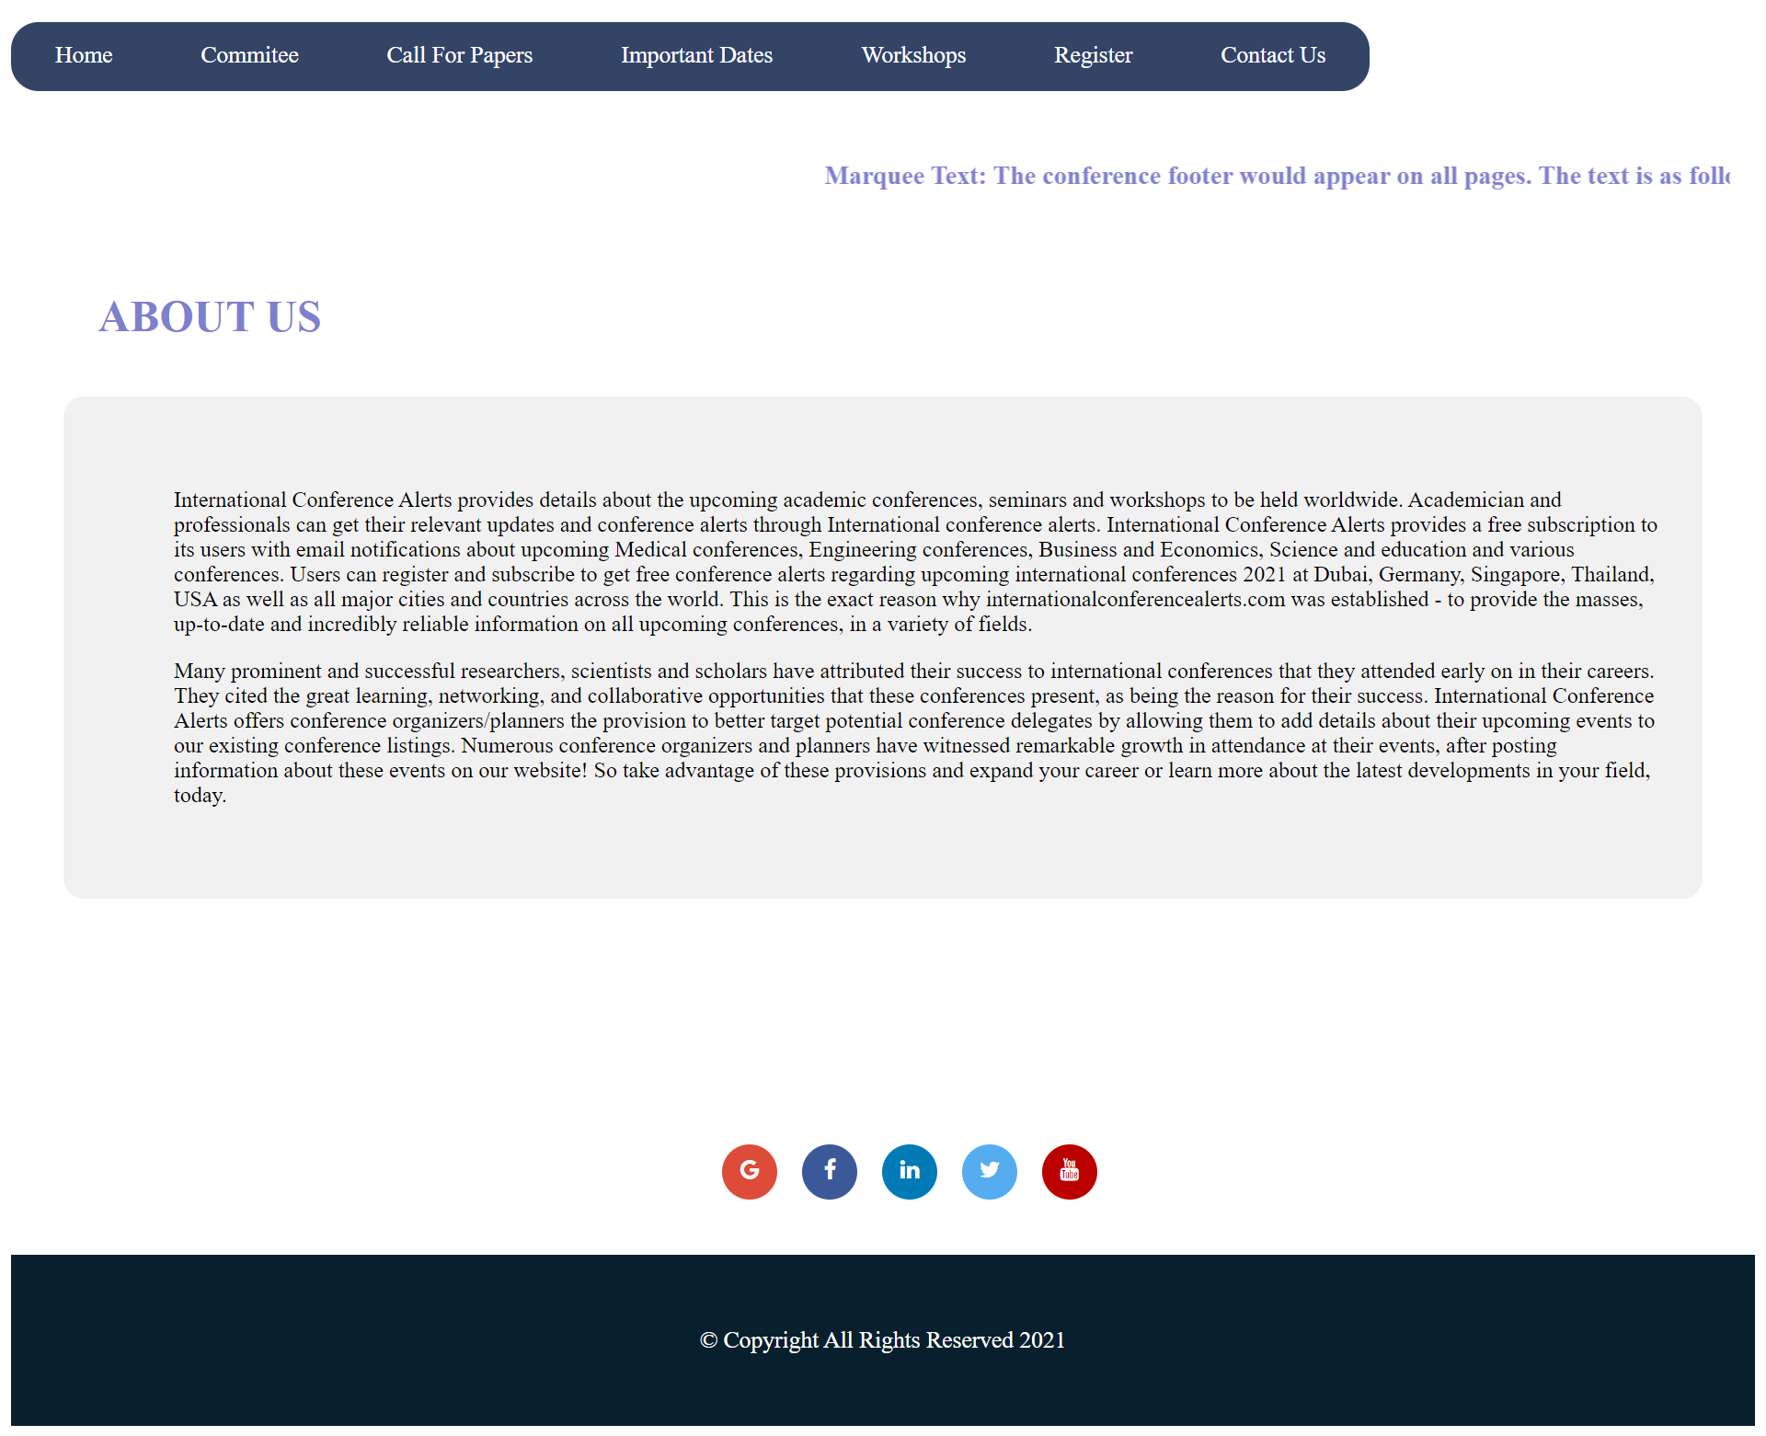

Conference Page

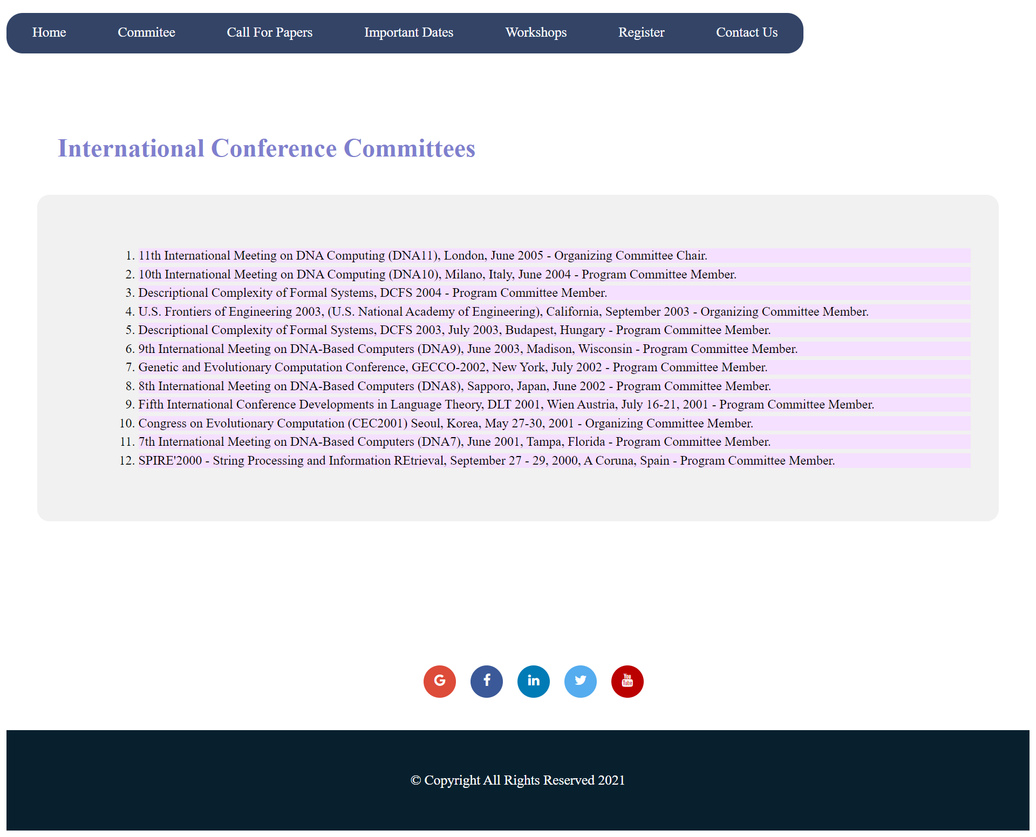

Call of Papers Page

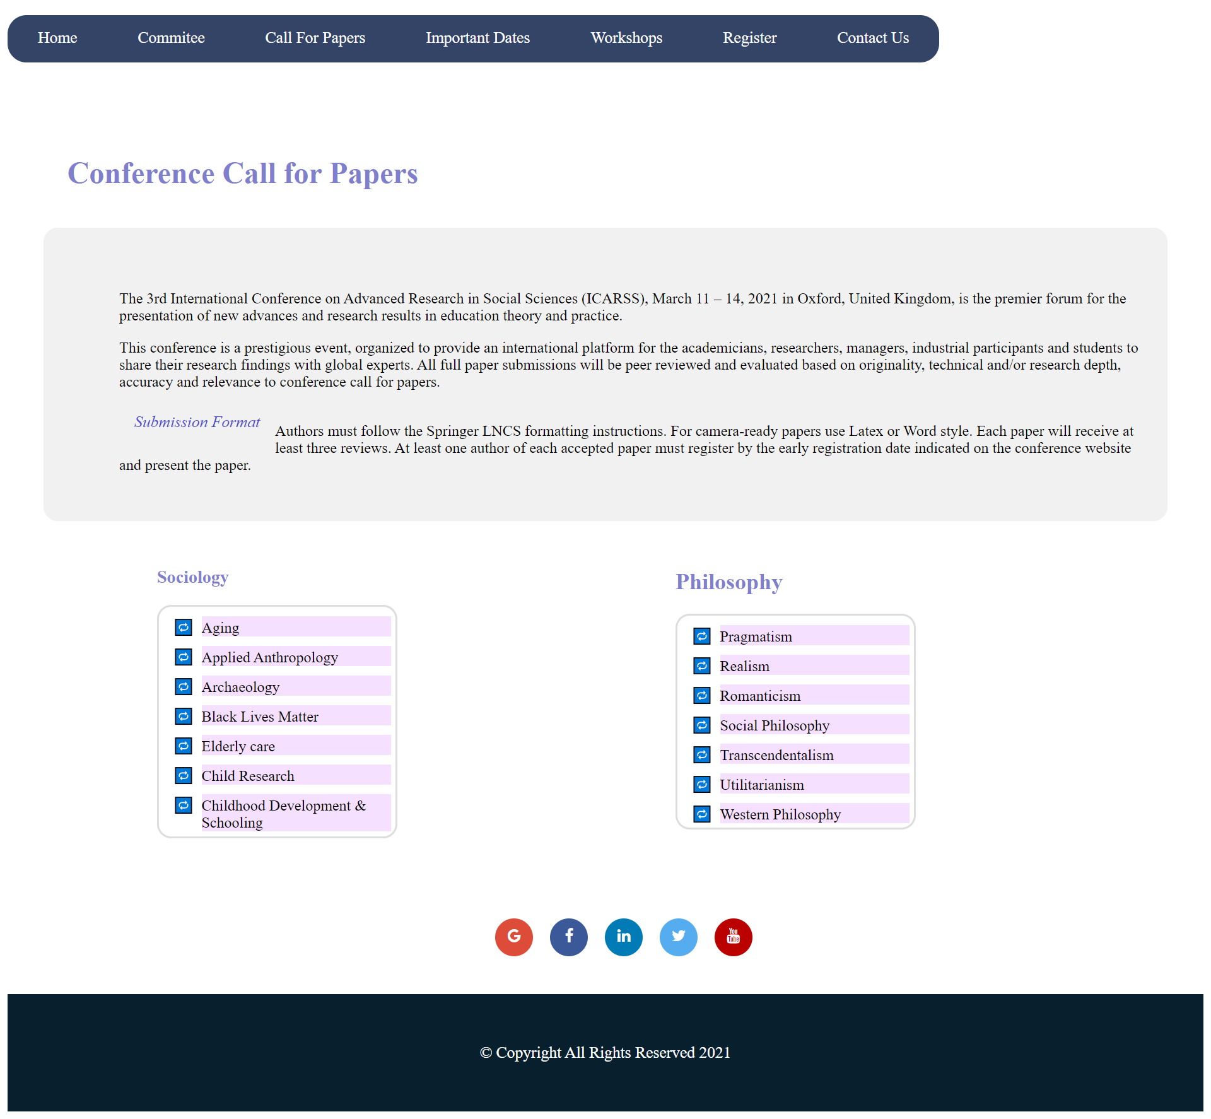

Important Dates Page

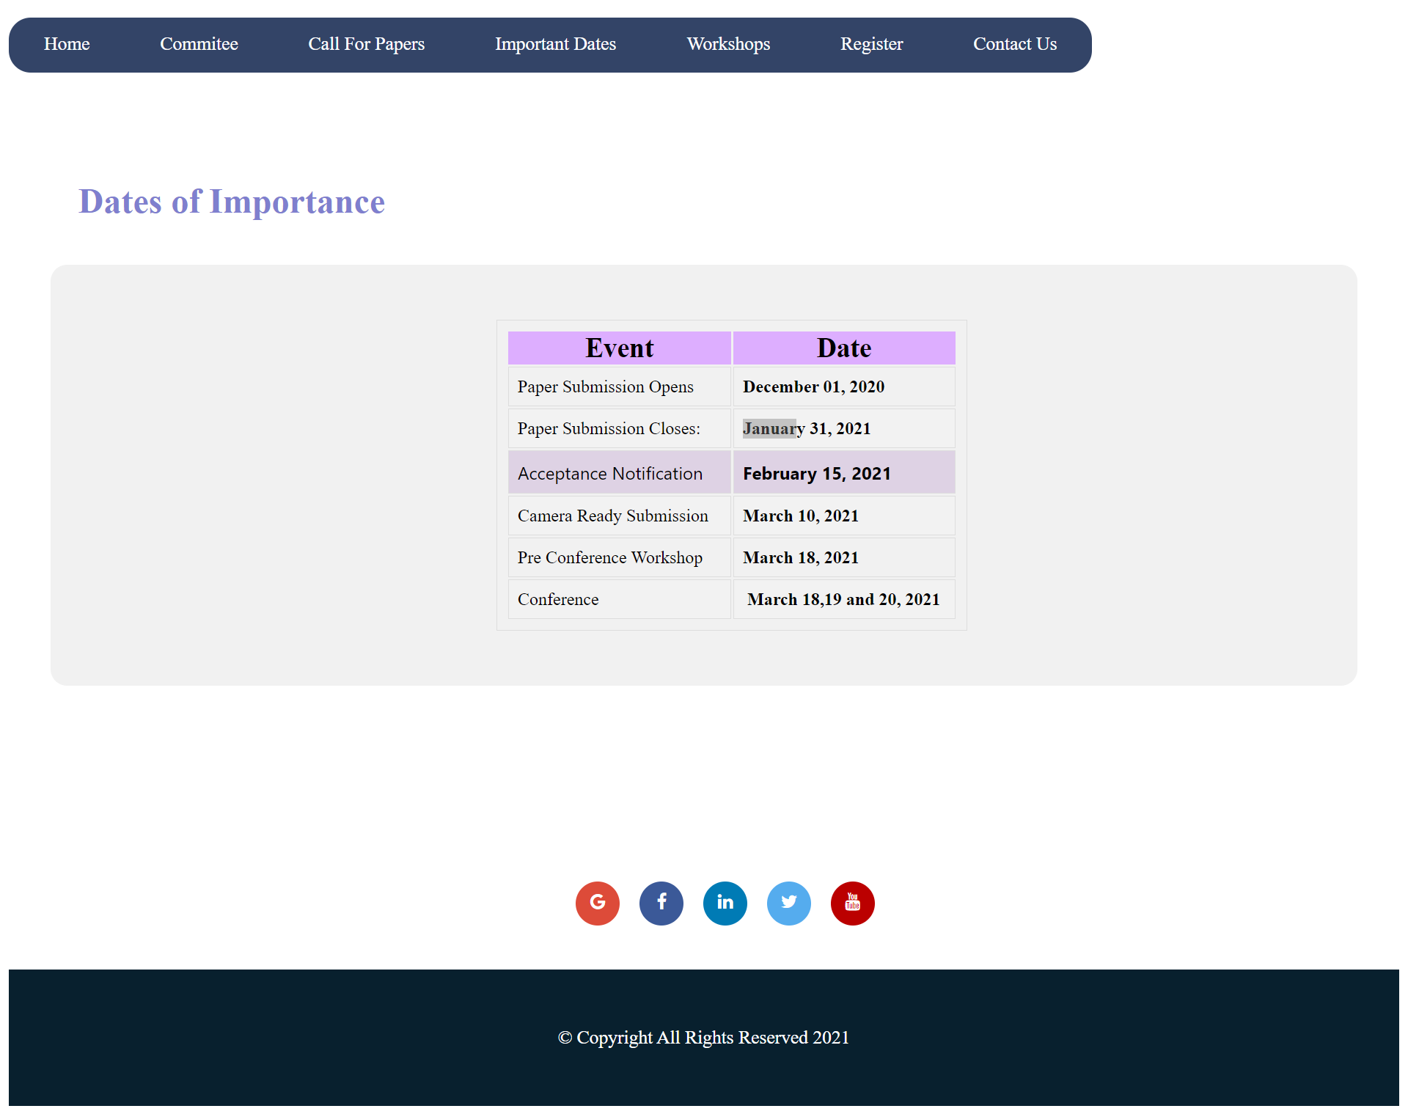

Workshop Page

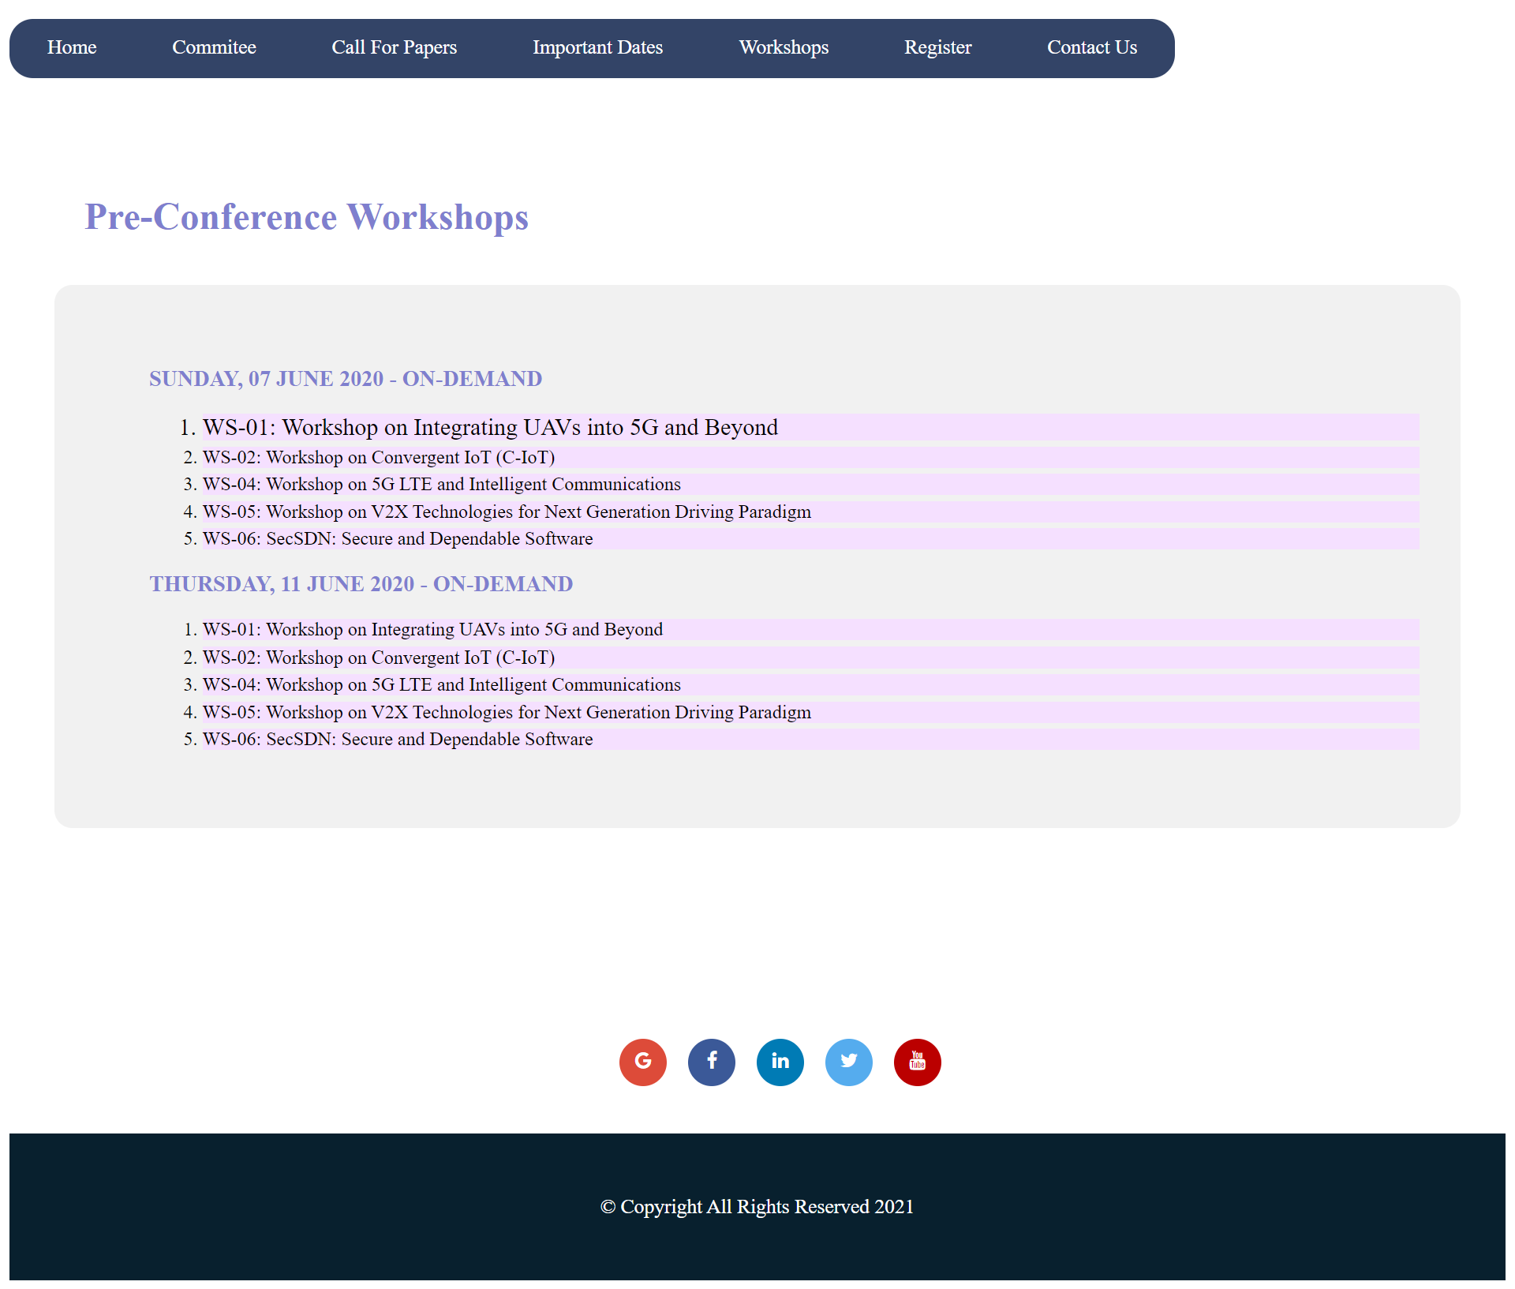

Contact Us Page

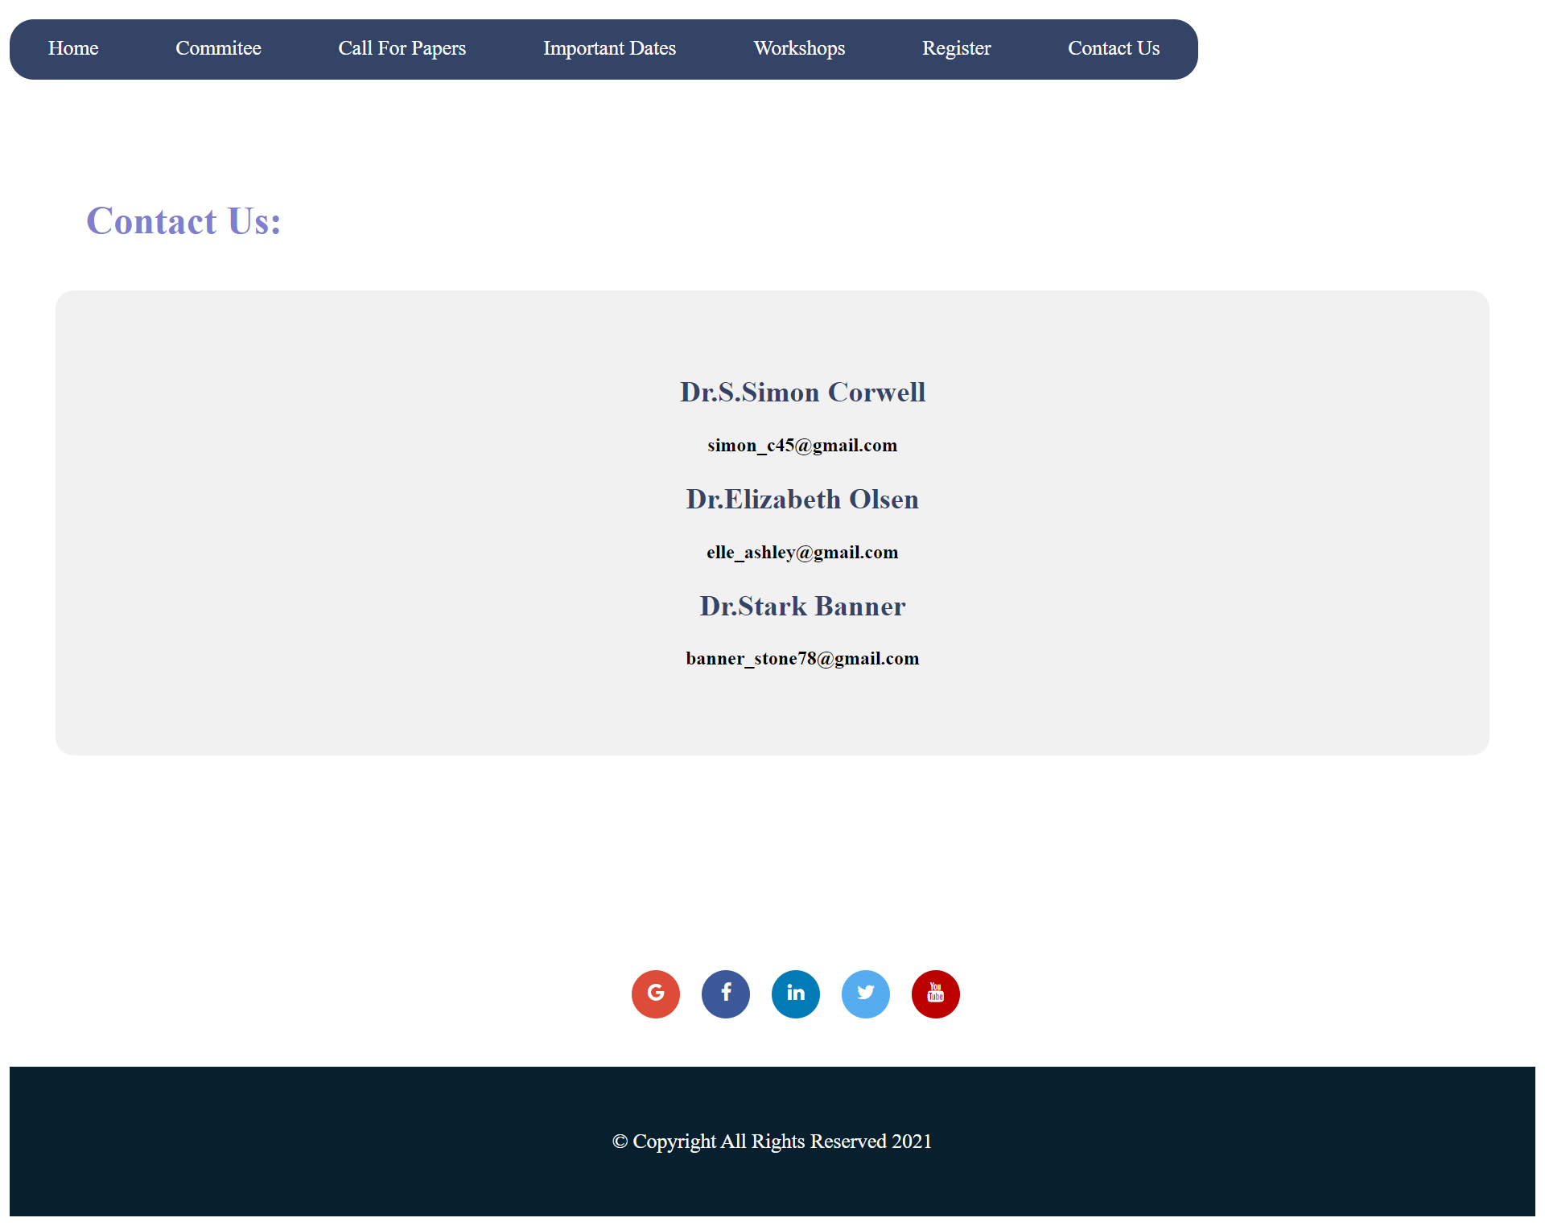

Registration Page

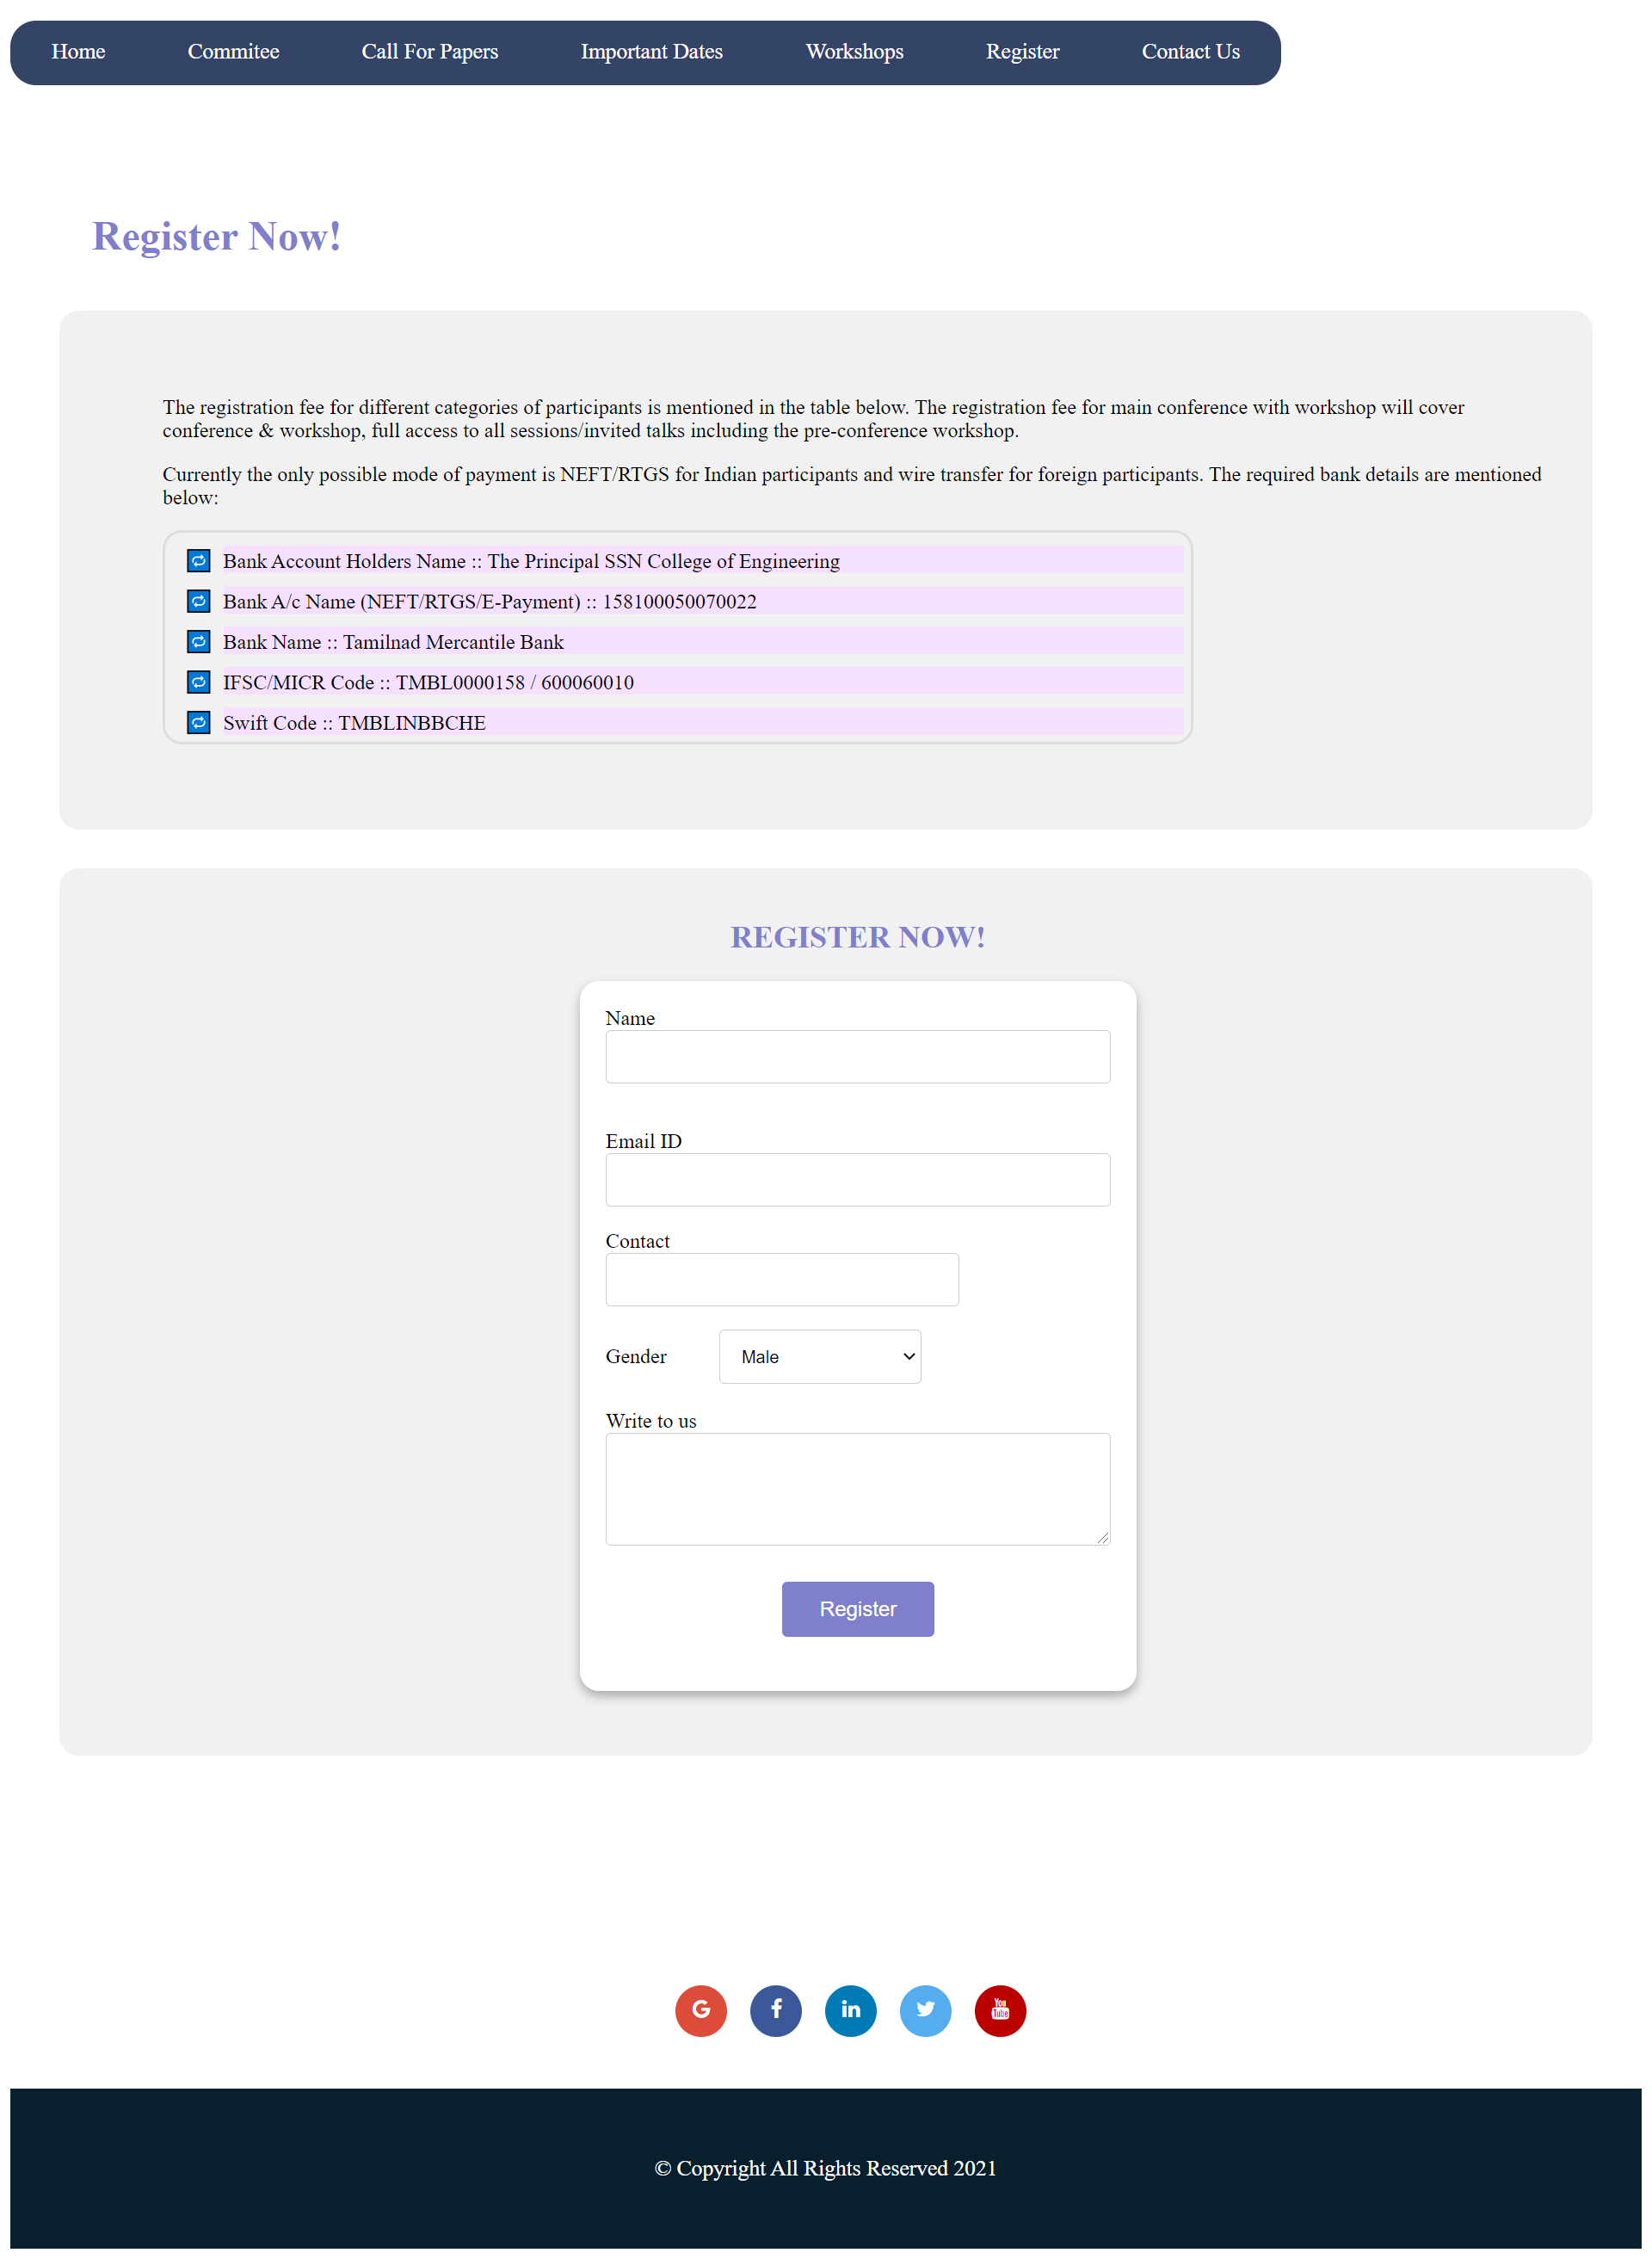

Directory Structure

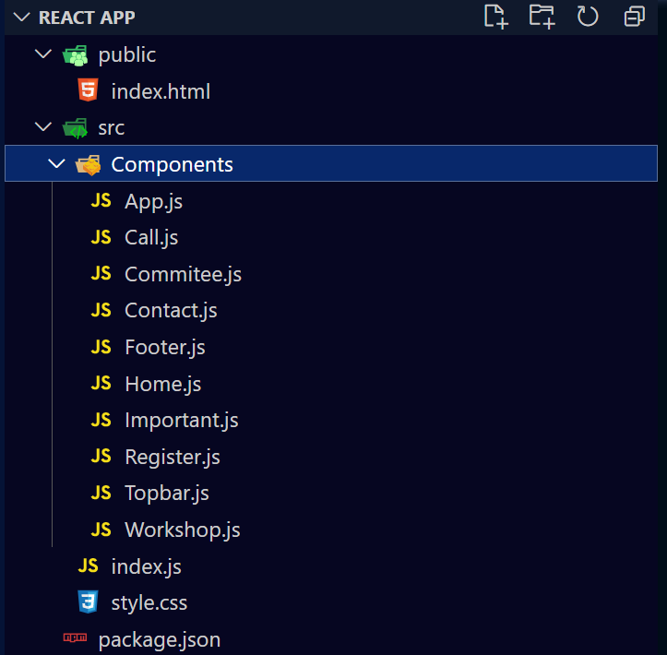

**LEARNING OUTCOME:**

* Understood that making user interfaces is easier to manipulate and make using component-based architecture.
* Learnt to write their apps within JavaScript and JSX features in doing so.
* Learnt to create and dynamically render component and understood that they are independent and reusable bits of code.
* Learnt to use the react router DOM library for enabling the navigation among views of various components, allowing changes in the browser URL, and keeps the UI in sync with the URL.
* Understood the need to use structure the React app that will allow to break down complex UI.
* Understood the importance of dynamic making web pages using React JS as they well-formed and flexible.